Online Bidding Website

Techniques: Spring MVC framework, Spring Security

Tasks to do:

derby db: database name: webProject

username: web

password: web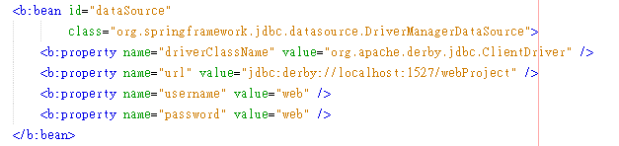

1. User Registration an Login

2. Index Page ( show the list of items for bidding)

3. Unregiserd users can read all content in the index page and item page

except bidding items.

4. Registered users can read content in the index page and item pages, and the followings:

a. create a new item page for bidding

b. end the bidding of owned item

c. bid a new item with his/her own price

d. write comments in item page

5. Admin can do all tasks in (4.) and the followings:

a. Edit(add,remove,update) the list of registered users and their information

b. Delete an item page or a comment in the item page.

Additional features:

1. Batch uploading of photos

2. Storing photos to the relational database